INTERNAL APPLICANT GUIDE

Our employees are our number one asset and we support your decision to expand and grow by exploring other opportunities within the organization! This guide should demonstrate how to apply for a position as a current COLSA employee.

ACCESSING COLSA’S INTERNAL CANDIDATE PORTAL
To view and apply to an opening as an internal employee, login to COLSA’s Internal Candidate Portal by going to this URL: https://colsainternal.silkroad.com .

SEARCHING FOR JOBS
To view COLSA’s open positions, click on “Employment Listings” at the top of the page. You should be brought to the main page where you can filter by category, location, and/or state. Click the “Search Jobs” button to view COLSA’s current job listings. Click on the position you wish to view and/or apply for.

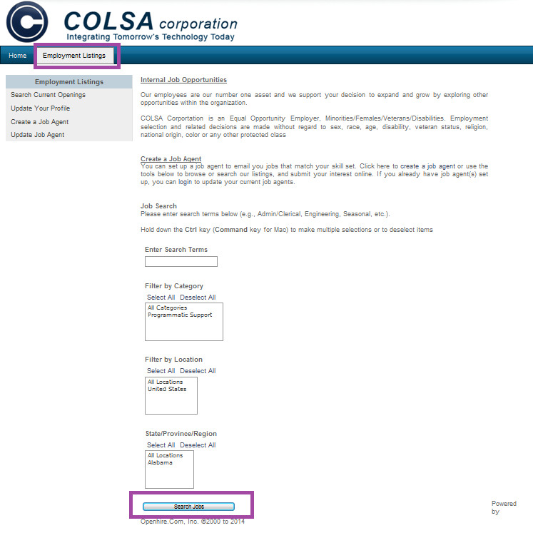

FIRST-TIME/NEW INTERNAL APPLICANTS

To apply to a position as a new internal applicant, click the “Submit New Resume” button at the bottom of the job posting.
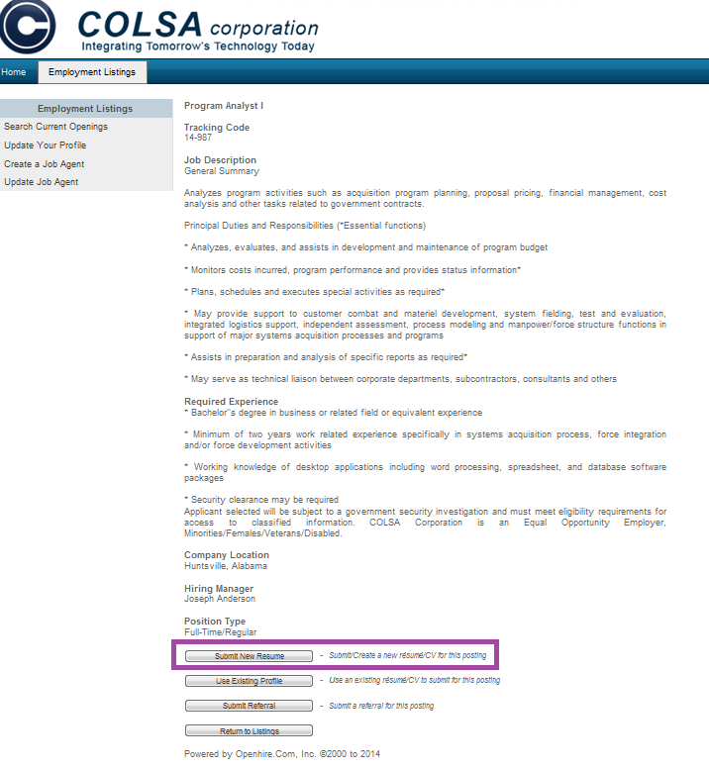

You will be asked to complete a short profile and upload your resume. You can use this profile to update your submission at a later time or to apply to other positions.

After you have created your profile and answered the necessary questions, a confirmation screen should appear stating that your submission for the position was successful.
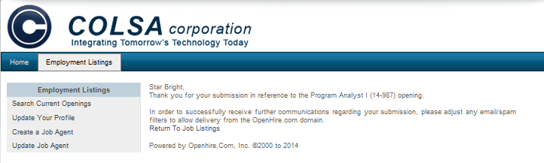

RETURNING INTERNAL APPLICANTS

If you have previously created a profile through the system, you may use that existing profile to apply to positions by clicking the “Use Existing Profile” button at the bottom of the job posting.

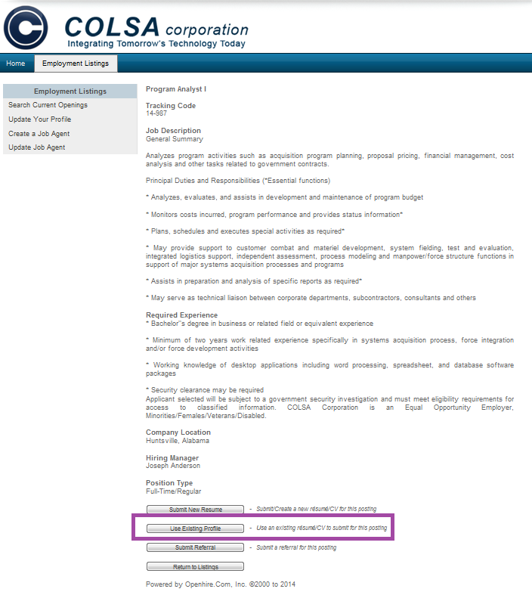

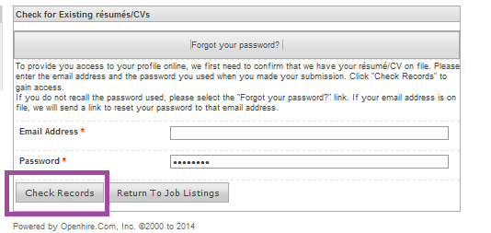
After clicking the button, you will be prompted to login with the email address and password you created as part of your profile. Click “Check Records” to login to your account.

Once you login, the previous positions you have applied for, along with links to the profile/resume submitted for each, will be displayed. You may view and/or edit each submitted profile/resume by clicking the “View Resume/CV” link.

To submit an existing profile/resume for a position, click the “Submit this Profile” link.

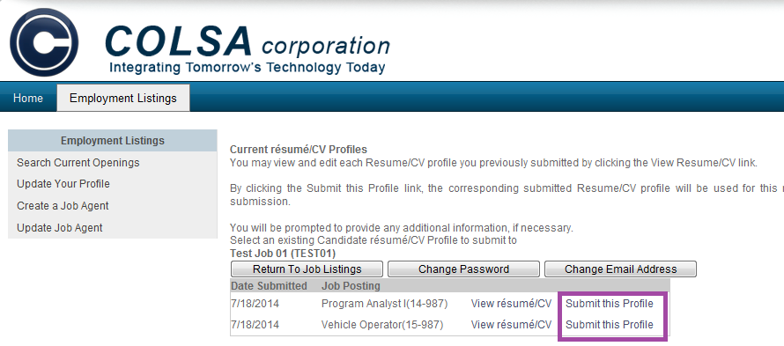

After clicking “Submit this Profile,” you may be asked to complete screening questions for the particular position you are applying for.

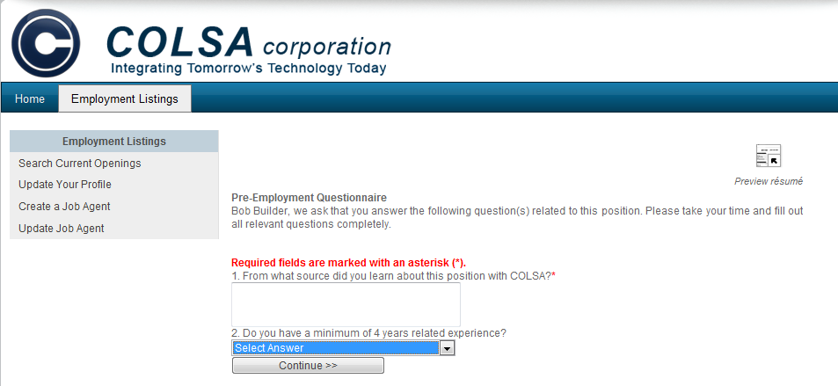

After you have answered any necessary questions, a confirmation screen should appear stating that your submission was successful.

INTERNAL CANDIDATE CONSIDERATION

After you have submitted your profile/resume to a position, your information will be routed to the position’s assigned Recruiter. He or she will carefully review your qualifications as related to the position and forward your information to the hiring manager if qualifications are met. Should your background and experience meet the hiring need, you will be contacted with further instructions.

EDITING YOUR PROFILE

Should you need to update your profile, click the “Update your Profile” from the Internal Candidate Portal homepage.
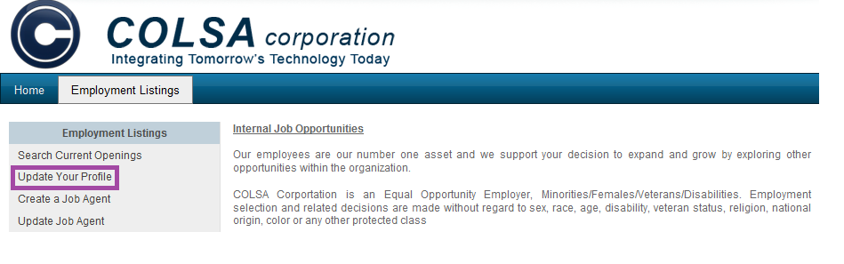

You will be prompted to login. After logging in, you will be shown the various positions you have applied to along with the profile/resumes submitted.

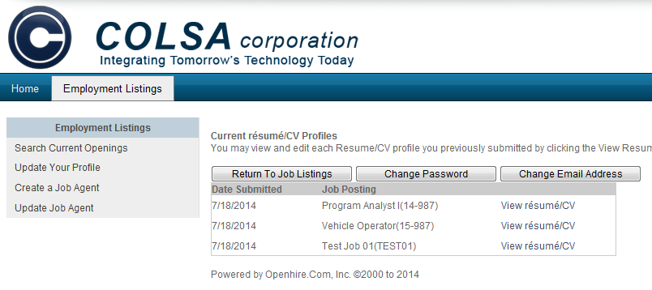
You may edit a profile/resume by clicking on the “View Resume/CV” link next to the one you would like to edit.

After selecting a profile/resume, the selected profile will display and contain links at the top to various sections of your profile---Contact Information, Internal Information, Work Authroization Status, Education, Additional Information, and Resume.

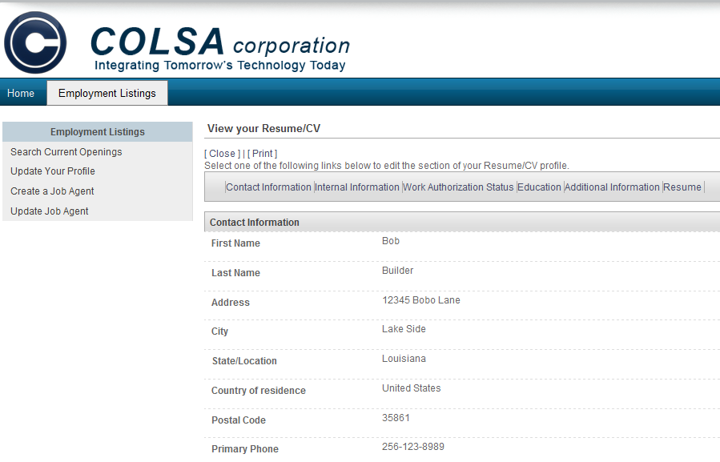

Click the section of your profile that you would like to edit. You will be able to edit the data contained in that section. After making changes, click “Save Changes” and your profile will be saved.

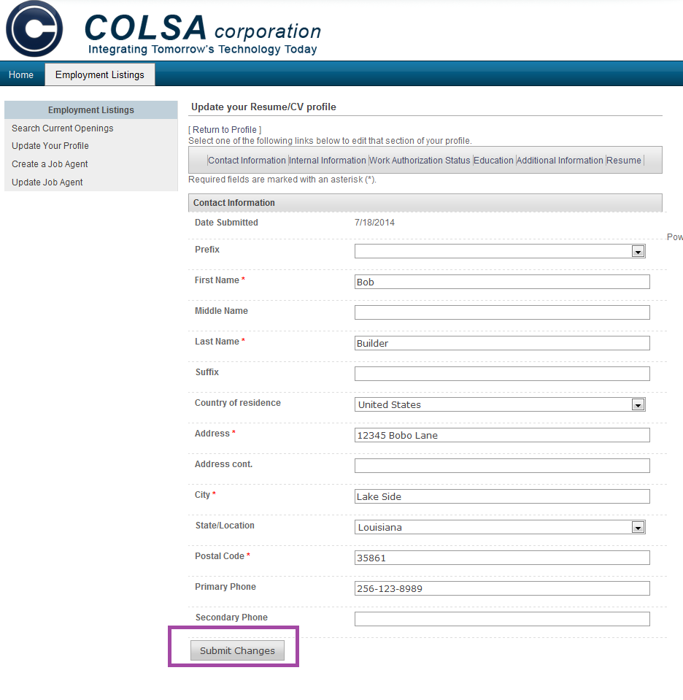

Questions regarding COLSA’s Internal Candidate Portal can be made to hr@colsa.com .

